Youth Empowerment Management System (YEMS)
- Users
- Member (youth) - Applicant
- District Administrator (DA) – First approver
- Funding Administrator (FA) – second approver, only after first approver
- System admin – IT admin

- Registration form (only Youth will register using this form)
- First Name
- Last Name
- Date of birth
- Telephone number
- User picture
- Province (see list below last 2 pages)
- District (see list below last 2 pages)
- Password
- Confirm password
- Membership number (auto generated)

- Upon submission - System to display “ Thank you for your registering, please complete the application form”
- After submission user should be taken to member profile
Application form
- Project name
- Industry (e.g Agriculture, Mining)
- Number of youth involved
- Funding required
- Payback period
- Application reference number (auto generated)
- Upload full proposal

Member profile
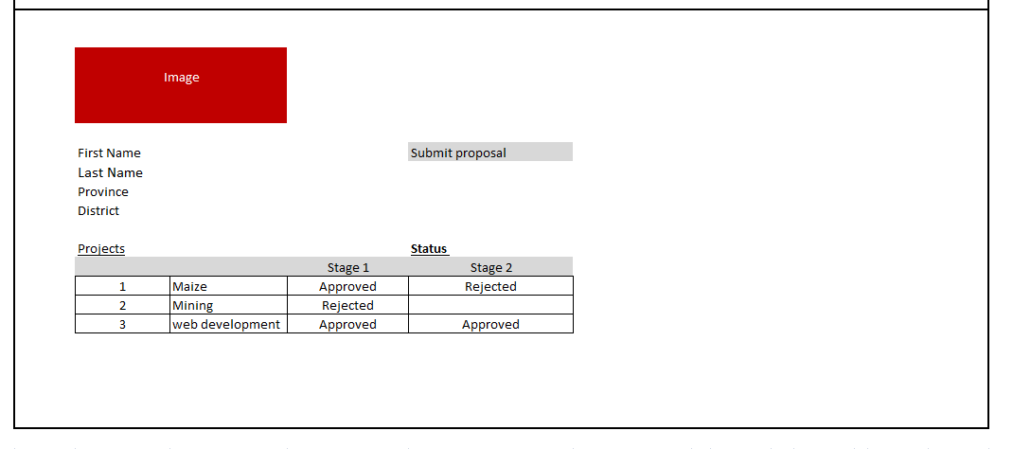

3.0 Login page (used by all users)
- Telephone number
- Password

4. 0 District Administrator (DA) - (will be created by systems admin)
- Must view only members in his district
- Must approve members for his district
- Can view all the projects in his district
- Must approve projects in his district

District Administrator (DA) - profile
- First name
- Last name
- Telephone number
- Province
- District
- Password
Approval form (dashboard)
All applications submitted will be pending approval
User should be able to approve or reject cases, approved change status to “approved projects”, rejected cases will move to “projects rejected”
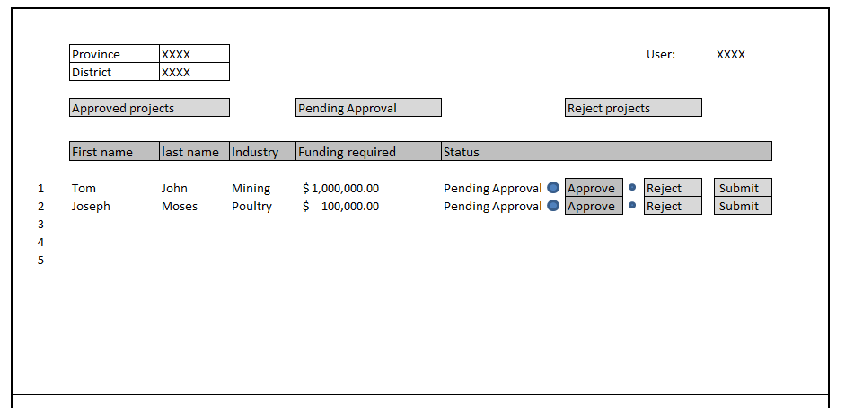

User should be able to click hyper link on First name that will open application form below . (this allows user to review the application before making decision)
Application form
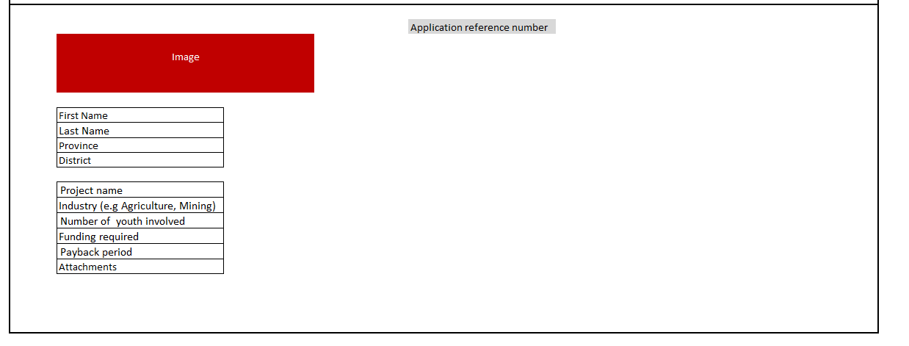

4.0. Funding Administrator (FA) – second approver – will be created by systems admin
- User will view all provinces & districts
- Users will only view Approved projects (approved by first approver)
Funding Administrator (FA) - profile
- First name
- Last name
- Organisation
- Telephone number
- Password
Approval form (dashboard)
All cases approved by District Administrator will be added to ” pending approval”
User should be able to approve or reject cases, approved change status to “approved projects”, rejected cases will move to “projects rejected”
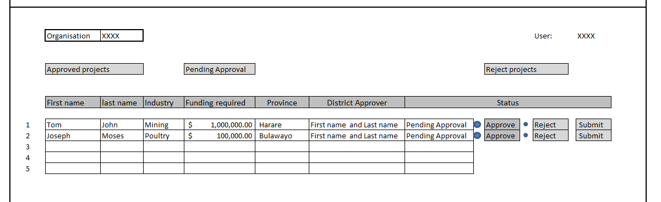
User should be able to click hyper link on First name that will open application form below . (this allows user to review the application before making decision)
Approval form
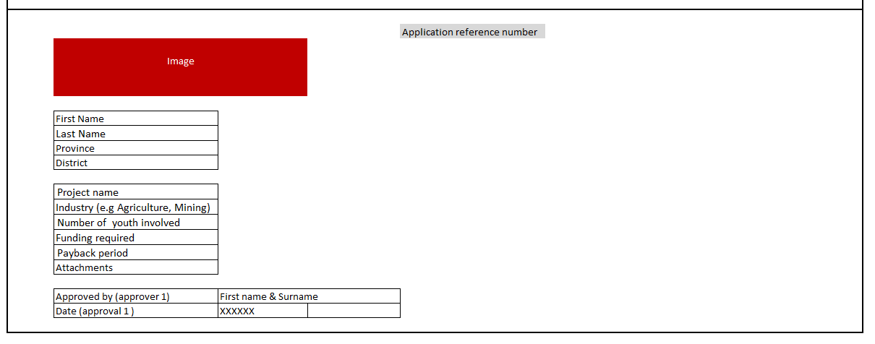

List of provinces and districts

- Bulawayo Province
- Bulawayo
- Harare Province
- Harare
- Manicaland Province
  - Buhera
  - Chimanimani
  - Chipinge
  - Makoni
  - Mutare
  - Mutasa
  - Nyanga
- Mashonaland Central Province
Districts of Mashonaland Central
- Bindura
- Guruve
- Mazowe
- Mbire
- Mount Darwin
- Muzarabani
- Mukumbura
- Rushinga
- Shamva

5.0 Mashonaland East Province

Districts of Mashonaland East
- Chikomba
- Goromonzi
- Marondera
- Mudzi
- Murehwa
- Mutoko
- Seke
- UMP (Uzumba-Maramba-Pfungwe)
- Wedza (Hwedza)

6.0 Mashonaland West Province

Districts of Mashonaland West
- Chegutu
- Hurungwe
- Kariba
- Makonde
- Mhondoro-Ngezi
- Sanyati
- Zvimba
- Kadoma

7.0 Masvingo Province

Districts of Masvingo
- Bikita
- Chiredzi
- Chivi
- Gutu
- Masvingo
- Mwenezi
- Zaka

8.0 Matabeleland North Province
Districts of Matabeleland North
- Binga
- Bubi
- Hwange
- Lupane
- Nkayi
- Tsholotsho
- Umguza

9.0 Matabeleland South Province
Districts of Matabeleland South
- Beitbridge
- Bulilima
- Gwanda
- Insiza
- Mangwe
- Matobo
- Umzingwane

10. Midlands Province

- Chirumhanzu
- Gokwe North
- Gokwe South
- Gweru
- Kwekwe
- Mberengwa
- Shurugwi
- Zvishavane

